Neuro-Adaptive Network Flow Orchestrator: A Deep Reinforcement Learning Approach for Proactive Congestion Control in Software-Defined Campus Networks
(Internal)

Dhruvin Hitesh Bhudia:169646

Supervisor: Mr. Tiberius Tabulu

An Informatics and Computer Science Project Proposal Submitted to the School of Computing and Engineering Sciences in partial fulfillment of the requirements for the award of a Degree in Bachelor of Science in Informatics and Computer Science

School of Computing and Engineering Sciences
Strathmore University
Nairobi, Kenya

June 2026

Declaration and Approval
The student declares that this project proposal has not been submitted to Strathmore University or any other University for the award of a Degree in Bachelor of Science in Informatics and Computer Science or any other Degree. To the best of the student's knowledge and belief, the research proposal contains no material previously published or written by another person except where due reference is made in the research proposal itself.

Student Admission Number: 169646

Sign: ________________________

Date: ________________________

Supervisor’s Signature:

Sign: ________________________

Date: ________________________

Acknowledgment
The researcher would like to extend heartfelt gratitude to the assigned supervisor, Mr. Tiberius Tabulu, for the unwavering support, technical guidance, and expert mentorship provided throughout the conceptualization and formulation of this research proposal.

Abstract
University campus networks must support fluctuating traffic generated by learning platforms, cloud services, video conferencing and digital research resources. Conventional shortest-path routing does not continuously optimize forwarding decisions using real-time congestion indicators, which may result in overloaded links, increased latency, packet loss and inefficient capacity utilization. Although Software-Defined Networking and Deep Reinforcement Learning have enabled adaptive traffic engineering, limited attention has been given to cost-conscious solutions that combine proactive routing with explicit mechanisms for controlling routing instability in campus environments. This project proposes a Neuro-Adaptive Network Flow Orchestrator that will use link utilization, queue occupancy, latency, throughput and packet-loss telemetry to generate congestion-aware routing decisions. The system will integrate a Deep Reinforcement Learning agent with a stability-control mechanism through the Ryu controller. It will be implemented and evaluated in reproducible campus-network scenarios using Mininet and PyTorch. Its performance will be compared with an OSPF-based baseline using end-to-end latency, throughput, packet-delivery ratio, maximum link utilization, congestion frequency and route-change frequency. The project is expected to determine whether stability-aware, software-defined traffic orchestration can reduce congestion and improve utilization of available network capacity under emulated campus traffic conditions.

Table of Contents
Declaration and Approval ii
Acknowledgment iii
Abstract iv
Table of Contents v
List of Tables ix
List of Abbreviations x
Chapter One: Introduction 1
1.1 Background 1
1.2 Problem Statement 2
1.3 General Objective 3
1.3.1 Specific Objectives 3
1.3.2 Research Questions 4
1.4 Justification 4
1.5 Scope and Limitations 5
1.5.1 Scope of the Project 5
1.5.2 Limitations and Delimitations of the Project 6
Chapter Two: Literature Review 7
2.1 Introduction 7
2.2 Network Telemetry Parameters Contributing to Congestion in Software-Defined Networking 7
2.2.1 Core Telemetry Metrics in Software-Defined Networking Routing 7
2.2.1.1 Traffic Volume and Link Utilization 8
2.2.1.2 Queue Occupancy and Buffer Management 8
2.2.1.3 Latency and Packet Loss 8
2.3 Review of Standard Routing and Intelligent Network Management Solutions 9
2.3.1 Standard Routing Processes and Network Management Challenges 9
2.3.2 Constraints of Enterprise Intelligent Platforms 10
2.3.2.1 Cisco DNA Center 10
2.3.2.2 Juniper Mist AI 11
2.3.2.3 Arista CloudVision 13
2.3.3 Emerging Machine Learning and Software-Defined Networking Implementations 14
2.3.4 Routing Stability in Reinforcement Learning-Based Traffic Engineering 16
2.4 Gaps in Existing Solutions 18
2.5 Conceptual Framework 18
Chapter Three: Development Methodology 21
3.1 Introduction 21
3.2 Research Paradigm 21
3.2.1 Data Acquisition 21
3.2.2 Data Preprocessing 22
3.2.3 Model Training 22
3.2.4 Model Validation and Testing 24
3.3 Software Development Methodology 25
3.3.1 Requirements Elicitation 27
3.3.2 System Prototyping 27
3.3.3 Algorithmic Integration 27
3.3.4 Iterative Refinement 27
3.3.5 Interface Construction 28
3.3.6 System Implementation 28
3.3.7 Testing and Deployment 28
3.4 System Analysis and Design 28
3.4.1 Use Case Diagram 28
3.4.2 Class Diagram 29
3.4.3 Entity Relationship Diagram 29
3.4.4 Database Schema 29
3.4.5 System Architecture 30
3.4.6 Wireframes 31
3.5 System Development Tools and Techniques 31
3.5.1 Mininet Network Emulator 32
3.5.2 Ryu Software-Defined Networking Framework 32
3.5.3 PyTorch Deep Learning Library 32
3.5.4 Deep Reinforcement Learning 32
3.5.5 Neuro-Adaptive Lyapunov Bounding 33
3.5.6 RESTful API Integration 33
3.6 System Deliverables 33
3.6.1 System Documentation 33
3.6.2 Authentication Module 34
3.6.3 Telemetry Module 34
3.6.4 NANFO Cognitive Routing Module 34
3.6.4.1 The Actor-Critic Brain 34
3.6.4.2 The Neuro-Adaptive Filter 34
3.6.5 Interactive Administrator Dashboard Module 35
References 36
Appendix 40
Appendix A1: Time Schedule 40
Appendix A2: Turn-It-In Report 41

Table of Figures
Figure 2.1. Cisco DNA Center Assurance Dashboard.. 11
Figure 2.2. Marvis conversational assistant interface.. 12
Figure 2.3. Arista CloudVision telemetry flow.. 13
Figure 2.4. Conceptual Framework Diagram 20
Figure 3.1. Hybrid Agile Development Lifecycle 26

List of Tables
Table 2.1: Comparative Analysis of Existing Intelligent Network Management and Traffic Engineering Approaches 16
Table 3.1: Relational Database Schema Specifications 30
Table 3.2: Hardware and Software Emulation Environment Specifications 31

List of Abbreviations
2FA - Two-Factor Authentication
A3C - Asynchronous Advantage Actor-Critic
AI - Artificial Intelligence
API - Application Programming Interface
BGP - Border Gateway Protocol
DDPG - Deep Deterministic Policy Gradient
DQN - Deep Q-Network
DRL - Deep Reinforcement Learning
ERD - Entity Relationship Diagram
GNN - Graph Neural Network
ICT - Information and Communication Technology
LAN - Local Area Network
MDP - Markov Decision Process
ML - Machine Learning
NANFO - Neuro-Adaptive Network Flow Orchestrator
OSPF - Open Shortest Path First
PPO - Proximal Policy Optimization
QoS - Quality of Service
SDN - Software-Defined Networking
UML - Unified Modeling Language

List of Equations
Equation 3.1: Traffic Matrix Formulation 22
Equation 3.2: System State Differential Equation 23
Equation 3.3: Neural Network Approximation 23
Equation 3.4: Lyapunov Stability Function 24
Equation 3.5: Neuro-Adaptive Update Law 24

Chapter One: Introduction

1.1 Background
Digital technologies have become central to the delivery of teaching, learning, research and administrative services in higher-education institutions. Universities increasingly depend on learning management systems, digital libraries, cloud-hosted applications, video-conferencing platforms, online assessment systems and real-time collaboration tools. The African Union’s Digital Education Strategy and Implementation Plan for 2023–2028 identifies digital infrastructure, including networks and devices, as a fundamental requirement for expanding the use of digital technologies in teaching, learning, research, assessment and educational administration. The strategy also recognizes the importance of developing sustainable school and campus networks across Africa (African Union Commission, 2022).
The increased dependence on digital platforms places substantial operational demands on university campus networks. A campus network provides communication among academic departments, administrative offices, laboratories, libraries, data centres and internet-based services. Unlike networks with relatively uniform demand, campus networks may experience considerable variations in traffic according to lecture schedules, examination periods, assignment deadlines, software-laboratory sessions and concurrent access to multimedia resources. These variations may include gradual increases in demand, sustained high-load periods and short traffic bursts. When several high-volume flows are directed through the same network links, the affected links may become heavily utilized while alternative paths remain underutilized. This condition can increase queue occupancy, end-to-end latency and packet loss while reducing throughput and packet-delivery performance.
Effective traffic engineering is therefore necessary to determine how network flows should be distributed across the available paths. Traffic engineering refers to the measurement, modelling and control of network traffic to improve performance and resource utilization. Relevant network-state information may include link utilization, traffic volume, queue occupancy, throughput, end-to-end latency and packet loss. These indicators do not perform identical roles. Link utilization indicates the proportion of available link capacity currently in use, while queue occupancy indicates the accumulation of packets waiting for transmission. Latency, packet loss and throughput provide additional evidence of the consequences of congestion. A traffic-engineering mechanism that considers several indicators may consequently develop a more complete representation of network conditions than one that relies on a single measurement.
Traditional campus and enterprise networks commonly use distributed routing protocols to provide reachability and respond to changes in network topology. Open Shortest Path First, or OSPF, is a link-state interior gateway protocol in which routers maintain a database representing the network topology and calculate routes by constructing a shortest-path tree. OSPF can recalculate routes following topology changes and can support equal-cost multipath routing (Moy, 1998). It should therefore not be described as an entirely static routing protocol. However, conventional OSPF path selection is principally based on configured link costs and topology information. It does not, by default, continuously predict congestion or optimize paths using a combined representation of instantaneous queue occupancy, link utilization and changing traffic demand.
This distinction is important because a path that is shortest according to configured OSPF costs may not always be the most suitable path under changing traffic conditions. If several flows continue to follow the same shortest path during a sudden increase in traffic, one or more links may become heavily loaded even when an alternative path has available capacity. OSPF can react to topology changes such as link or router failures, but congestion may occur without a corresponding topology change. Consequently, a mechanism that depends mainly on shortest-path calculations may not redistribute flows merely because queue occupancy or link utilization has increased. This creates an opportunity for traffic-engineering solutions that can use current network conditions when selecting paths.
Software-Defined Networking provides a programmable approach through which this limitation may be investigated. SDN separates network-control logic from the underlying packet-forwarding devices and places the control function in a logically centralized controller. This separation gives the controller a wider view of network conditions and enables forwarding policies to be installed programmatically. The controller can collect statistics from network devices, process network-state information and communicate updated flow rules to the data plane. These capabilities make SDN suitable for research into dynamic traffic engineering, because routing policies can be adjusted according to observed conditions rather than being limited to distributed shortest-path calculations (Kreutz et al., 2015).
Although SDN provides centralized visibility and programmability, it does not independently determine the best traffic-engineering decision for every possible network state. Rule-based SDN applications may use predefined thresholds, such as rerouting traffic when link utilization exceeds a selected limit. Such rules can be effective in known conditions, but they may be insufficient where traffic patterns are highly variable or where several network indicators interact. A fixed threshold may also cause repeated routing changes when a monitored value fluctuates around the threshold. Therefore, an intelligent decision mechanism is required to interpret the collected telemetry, compare available actions and select a routing response appropriate to the current and anticipated condition of the network.
Machine learning, particularly Deep Reinforcement Learning, has emerged as a possible mechanism for making adaptive traffic-engineering decisions. In reinforcement learning, an agent interacts with an environment, observes the environment’s state, selects actions and receives rewards or penalties according to the consequences of those actions. In an SDN traffic-engineering context, the state may contain link utilization, queue occupancy, latency, throughput and packet-loss measurements. The action may involve selecting a path, modifying link weights or allocating traffic across multiple paths. The reward can be constructed to discourage congestion, delay and packet loss while encouraging high throughput and balanced link utilization.
Research has demonstrated the potential of combining Deep Reinforcement Learning with SDN to support adaptive routing under changing traffic conditions. For example, DRL-based routing studies have compared learned routing policies with conventional approaches such as shortest-path routing and OSPF, using metrics including throughput, latency and link utilization. One adaptive traffic-routing study integrating graph-based learning with DRL reported improved throughput and reduced delay relative to an OSPF comparison under its experimental conditions. These results demonstrate the potential of learned traffic-engineering policies, but they do not establish that every DRL implementation will outperform OSPF in every network or traffic scenario. The effectiveness of a DRL solution depends on its state representation, action space, reward function, training procedure, topology and evaluation conditions.
The adaptive nature of DRL also introduces an important operational challenge. A learning agent may respond to small or temporary changes in network telemetry by repeatedly selecting different paths. Excessive route changes can increase the number of flow-rule updates issued by the SDN controller, add controller overhead, cause packet reordering and reduce forwarding predictability. A routing mechanism may therefore improve an individual performance indicator while still producing undesirable instability. For this reason, routing stability should be evaluated explicitly rather than assumed from improvements in throughput or latency. Relevant stability indicators may include route-change frequency, flow-rule update rate, average path-holding time, packet reordering and controller overhead.
The literature reviewed in the submitted proposal indicates that existing intelligent traffic-engineering studies address areas such as adaptive routing, topology-aware learning, state-space reduction, load balancing and generalization across network topologies. However, the proposal also identifies continuing limitations concerning routing stability, computational complexity, applicability to resource-constrained campus networks and reliance on proprietary network-management platforms. Commercial systems may provide extensive monitoring, assurance and automation, but their suitability depends on the supported hardware, product architecture, subscription arrangements and institutional resources. Product-specific claims concerning Cisco Systems, Juniper Networks or Arista Networks must therefore be supported individually by authoritative documentation or independent studies rather than by a single general vendor citation.
Within the context of this project, there is a need to investigate an accessible and reproducible traffic-engineering approach that combines centralized SDN telemetry, adaptive DRL decision-making and an explicit routing-stability mechanism. The proposed Neuro-Adaptive Network Flow Orchestrator will address this need within an emulated campus-network environment. The project will use Mininet to construct the experimental topology, the Ryu controller to collect network telemetry and install forwarding rules, and PyTorch to implement the learning agent. The use of an emulated environment will allow controlled and repeatable experiments without interfering with a live institutional network.
The proposed system will observe link utilization, queue occupancy, latency, throughput and packet loss and use these measurements to determine congestion-aware flow-allocation decisions. For this project, proactive congestion mitigation should be defined operationally as initiating a traffic-engineering action before the experiment’s predefined congestion condition is reached. The specific congestion threshold or combined condition must be established and justified in the methodology rather than assumed in Chapter One. The system will also include a stability-control mechanism intended to limit excessive route changes generated during adaptation.
The developed orchestrator will be compared with a consistently configured OSPF-based baseline under normal, burst and sustained high-load traffic scenarios. Evaluation will use end-to-end latency, throughput, packet-delivery ratio, maximum link utilization and congestion-occurrence frequency. Because routing stability forms part of the identified research gap, route-change frequency, flow-rule update rate and controller overhead will also be evaluated. The study will therefore determine whether a stability-aware DRL orchestrator can improve congestion-related performance in the emulated campus environment without generating excessive routing changes. It will not claim to prove performance on the live Strathmore University network unless authorized institutional data and production-network testing become available.

1.2 Problem Statement
University campus networks support traffic whose volume and distribution can change considerably across learning, administrative and research activities. Conventional shortest-path routing can provide reliable reachability but does not ordinarily adjust forwarding decisions continuously according to predicted traffic demand, current queue occupancy and instantaneous link utilization. Consequently, multiple flows may continue to use an increasingly loaded path while alternative capacity remains underutilized, increasing the risk of delay, packet loss and throughput degradation.
Software-Defined Networking provides centralized visibility and programmable flow control, while Deep Reinforcement Learning offers a mechanism for learning traffic-engineering policies from changing network conditions. However, existing approaches do not fully resolve three related requirements for the proposed study context: proactive congestion mitigation using multiple telemetry indicators, control of excessive route changes during adaptation and implementation using an accessible software-based environment suitable for a campus network. Commercial platforms may also depend on particular vendor ecosystems or licensing arrangements, while research prototypes are frequently evaluated in settings that do not directly represent dynamic campus traffic.
The unresolved problem is therefore the lack of an experimentally validated, stability-aware traffic-engineering framework that can use real-time telemetry to redistribute flows before predefined congestion conditions are reached in an emulated campus network. Without such a framework, congestion-mitigation decisions may remain reactive, available path capacity may be underutilized and highly adaptive routing may introduce excessive route changes. This project will address the problem by developing and evaluating a Deep Reinforcement Learning-based network flow orchestrator in a Software-Defined Networking environment, comparing it with a defined OSPF-based baseline using congestion, performance and routing-stability metrics.

1.3 General Objective
To design, implement and experimentally evaluate a stability-aware Deep Reinforcement Learning network flow orchestrator for proactive congestion mitigation in an emulated Software-Defined campus network during the project period.

1.3.1 Specific Objectives
i. To characterize congestion in an emulated Software-Defined campus network by measuring link utilization, queue occupancy, latency, throughput and packet loss under normal, burst and sustained high-load traffic scenarios.
ii. To characterize congestion in an emulated Software-Defined campus network by measuring link utilization, queue occupancy, latency, throughput and packet loss under normal, burst and sustained high-load traffic scenarios.
iii. To integrate a stability-control mechanism that constrains excessive routing changes and to quantify its effect using route-change frequency, flow-rule update rate and controller overhead.
iv. To compare the developed Neuro-Adaptive Network Flow Orchestrator with a consistently configured OSPF-based baseline across repeated campus-traffic experiments using end-to-end latency, throughput, packet-delivery ratio, maximum link utilization, congestion-occurrence frequency and route-change frequency.

1.3.2 Research Questions
i. How do link utilization, queue occupancy, latency, throughput and packet loss vary under normal, burst and sustained high-load traffic scenarios in an emulated Software-Defined campus network?
ii. How can a Deep Reinforcement Learning flow-orchestration agent use real-time network telemetry to redistribute traffic before the predefined congestion condition is reached?
iii. To what extent can a stability-control mechanism constrain route changes, flow-rule updates and controller overhead during adaptive traffic engineering?
iv. How does the developed Neuro-Adaptive Network Flow Orchestrator compare with an OSPF-based baseline in terms of end-to-end latency, throughput, packet-delivery ratio, maximum link utilization, congestion-occurrence frequency and route-change frequency?

1.4 Justification
The development of the Neuro-Adaptive Network Flow Orchestrator (NANFO) system will be highly justified from technical, economic, and operational perspectives. Technically, relying on reactive routing protocols in an era of cloud computing and heavy multimedia usage results in unacceptable latency and severe service degradation. By leveraging a Software-Defined Networking paradigm, the control plane will be physically decoupled from the data plane, granting a centralized software controller a comprehensive, global view of the network state. Integrating Deep Reinforcement Learning into the SDN controller may provide a mechanism for adaptive traffic management capable of responding to changing network conditions. thereby transforming a static, unyielding network into an autonomous, self-healing system capable of intelligent load balancing.
From an academic perspective, the study contributes to the growing body of research on the application of Deep Reinforcement Learning within Software-Defined Networking environments. The findings may provide insights into the effectiveness of adaptive traffic engineering approaches for congestion mitigation in resource-constrained campus networks, thereby informing future research and practical deployments in higher education institutions.
Economically, the proposed project perfectly aligns with the principles of frugal innovation, which is highly relevant to the Kenyan higher education market. Frugal innovation focuses on reducing the complexity and cost of a service while retaining or enhancing core functionalities (Bariu, 2020). Instead of relying on capital-intensive hardware upgrades to alleviate bottlenecks, the NANFO approach will extract maximum utility from existing switches and cabling through intelligent software orchestration. This approach has the potential to reduce infrastructure upgrade requirements and associated operational costs. for institutional networks, making high-performance connectivity accessible and sustainable despite severe budget constraints and prohibitive import taxes. Furthermore, the inclusion of adaptive power-saving protocols will directly address the unique infrastructural challenge of frequent power outages in the region, ensuring that critical academic services remain online longer during grid failures by dynamically shutting down redundant switch ports during periods of low utilization.

1.5 Scope and Limitations

1.5.1 Scope of the Project
This project will encompass the theoretical formulation, software development, and simulated deployment of the NANFO system. The core scope includes the strict architectural separation of the underlying network data plane from the centralized control function, enabling the SDN controller to calculate and enforce dynamic routing decisions within the emulated environment. Furthermore, it involves the design of a Deep Reinforcement Learning (DRL) agent equipped with routing stability mechanisms to drive these traffic engineering processes, alongside the development of a comprehensive administrator dashboard for real-time visualization. To ensure rigorous evaluation without disrupting active campus infrastructure, the implementation will heavily rely on network emulation for testing. This will be strictly confined to a virtualized environment utilizing the Mininet emulator and the Ryu SDN framework to accurately replicate the complex topological conditions and traffic dynamics of a university campus network.

1.5.2 Limitations and Delimitations of the Project
The primary limitation of this project involves the inability to deploy and test the NANFO system on the live, physical production network of Strathmore University due to the inherent risks of causing operational downtime during the experimental training phases of the reinforcement learning agent. Consequently, the model's efficacy must be evaluated using synthetic traffic matrices and historical data logs generated within an emulated environment, which may not capture every unpredictable anomaly present in real-world physical transmission media. Furthermore, the intensive computational overhead required to train deep neural networks is inherently constrained by the processing capabilities of the available development hardware. To strategically mitigate these environmental and hardware limitations, deliberate delimitations have been established to maintain a highly focused and achievable research trajectory. To reduce simulation complexity, the study will strictly confine its scope to wired Ethernet routing and local area network flow orchestration, explicitly excluding the analysis of wireless spectrum sharing mechanisms, radio access network optimizations, and cellular 5G slicing. Additionally, to align with the constraints of the emulated testing environment, the project entirely excludes the development of custom physical hardware switches, relying instead on the standard OpenFlow protocol to communicate with virtual software switches. Finally, to ensure the reinforcement learning agent's training remains computationally feasible and conceptually targeted, security and intrusion detection mechanisms will fall completely outside the study's purview, dedicating all system resources and research efforts strictly to performance optimization, traffic engineering, and congestion mitigation.

Chapter Two: Literature Review

2.1 Introduction
The evolution of enterprise and academic network management has increasingly shifted toward automation, programmability, and artificial intelligence to cope with the explosive growth of connected devices and data-intensive applications. This chapter will review the state of academic network infrastructure in developing nations, specifically focusing on the severe challenges of hardware acquisition and maintenance in the Kenyan market. It will further evaluate the paradigm shift from traditional, decentralized routing to Software-Defined Networking and thoroughly critique recent scholarly applications that explore the integration of Machine Learning for traffic engineering. Finally, the review will identify the critical mathematical and practical gaps in algorithmic implementations, paving the way for the conceptual framework of the neuro-adaptive approach proposed in this study.

2.2 Network Telemetry Parameters Contributing to Congestion in Software-Defined Networking
Software-Defined Networking (SDN) has fundamentally reshaped traffic management by decoupling the control plane from the data plane, allowing for centralized, programmable routing. A cornerstone of this architecture is the ability to leverage protocols like OpenFlow and In-band Network Telemetry (INT) to collect real-time, hop-by-hop network status information directly through the data plane, subverting traditional methods that treat switches as inaccessible black boxes (Wang et al., 2023). To fully satisfy the objective of analyzing network telemetry parameters that contribute to congestion, it is critical to dissect the specific state-space inputsnamely traffic volume, link utilization, queue occupancy, latency, and packet loss. While Tang et al. (2024) emphasize link utilization as the primary congestion indicator, Zhou and Liu (2024) argue that queue occupancy provides earlier warning signals due to its direct relationship with buffer saturation. TWang et al. (2023) identify these metrics as critical indicators for congestion detection and routing optimization in SDN environments.

2.2.1 Core Telemetry Metrics in Software-Defined Networking Routing
In high-density environments like university campuses, traffic is rarely uniform. It is characterized by extreme volatility and sudden micro-bursts, heavily impacting the physical infrastructure's ability to maintain Quality of Service (QoS). SDN controllers must extract specific, granular telemetry data to feed into Deep Reinforcement Learning (DRL) algorithms to preempt congestion (Tang et al., 2024).

2.2.1.1 Traffic Volume and Link Utilization
Traffic volume refers to the absolute amount of data transiting a network, while link utilization measures the percentage of a network link's total bandwidth currently in use. During sudden campus micro-bursts such as thousands of students concurrently streaming multimedia at the end of a lecture traffic volume spikes abruptly. When utilizing traditional routing protocols, these bursts frequently converge on the shortest path links, driving link utilization to its absolute maximum capacity (Maximum Link Utilization, or MLU) and throttling overall throughput (Nguyen et al., 2024). As link utilization approaches 100%, the network's ability to absorb transient traffic spikes vanishes. Centralized SDN controllers monitor these two parameters in real-time to identify asymmetric loads, allowing the DRL agent to autonomously distribute flows across underutilized paths, thereby minimizing MLU across the topology (Tang et al., 2023).

2.2.1.2 Queue Occupancy and Buffer Management
Queue occupancy acts as a highly sensitive, preemptive indicator of impending network failure. When bursty traffic volume exceeds the active transmission rate of a switch port, excess packets are temporarily stored in hardware buffers. Sustained traffic bursts can lead to a severe condition known as bufferbloat, where long-lived flows persistently occupy limited buffer space, preventing new, short-lived requests from securing allocation (Zhou & Liu, 2024). Monitoring exact queue depth via SDN telemetry allows an intelligent orchestrator to detect congestion before the buffers physically overflow. This foresight enables the controller to preemptively shape traffic, regulate packet transmission rates, or enforce strict bandwidth priorities.

2.2.1.3 Latency and Packet Loss
If elevated queue occupancy is not proactively mitigated, hardware buffers inevitably overflow, triggering unavoidable packet loss through mechanisms such as tail-drop. Packet loss acts as a destructive catalyst in IP networks; it forces the Transmission Control Protocol (TCP) to initiate rigid congestion avoidance algorithms and aggressively retransmit dropped packets. This cycle exponentially increases end-to-end latency and further saturates the already congested bottleneck links (Zhou & Liu, 2024). In a high-demand academic network, compounding latency severely degrades the performance of real-time applications. By treating high latency and packet loss as negative reward signals (penalties), neuro-adaptive reinforcement learning models iteratively train to calculate routing paths that circumvent congested nodes entirely, preserving semantic continuity across the network (Gamel et al., 2024).

2.3 Review of Standard Routing and Intelligent Network Management Solutions
To fully contextualize the necessity of the Neuro-Adaptive Network Flow Orchestrator (NANFO), it is critical to review both standard routing approaches and existing intelligent network management solutions. Examining these mechanisms highlights their inherent limitations in addressing dynamic, burst-driven network congestion, thereby justifying the transition to a predictive, DRL-based model.

2.3.1 Standard Routing Processes and Network Management Challenges
In traditional distributed networks, data transmission relies heavily on standard link-state routing processes such as Open Shortest Path First (OSPF). These standard routing protocols calculate the optimal path between nodes based on static link weights (e.g., link speed or administrative distance) and forward packets rigidly along those predetermined paths (Al-Sadi et al., 2023). While computationally inexpensive, these shortest-path-first methods fundamentally ignore real-time network load balancing. Their link options remain static; thus, they fail to adaptively adjust routing schemes when encountering sudden fluctuations in traffic demand.
To overcome the rigid nature of standard routing, enterprise architectures shifted toward intelligent network management paradigms, including Software-Defined Networking (SDN) and Software-Defined Perimeters (SDPs). SDN centralizes the control plane, theoretically allowing for dynamic, adaptive routing based on real-time network states. However, existing adaptive management solutions still face profound challenges. Many current SDN controllers rely on reactive threshold-based heuristicshey only calculate new path options after telemetry indicates that congestion thresholds (like high link utilization) have already been breached (Wang et al., 2023). Furthermore, integrating secure, identity-driven overlays like SDPs adds computational overhead, often exacerbating latency during the dynamic rerouting process (Nguyen et al., 2024). Consequently, the inability of legacy standard routing to react to dynamic bursts, coupled with the purely reactive (rather than predictive) nature of current SDN adaptive management, results in chronic congestion and sub-optimal utilization of existing network infrastructure.

2.3.2 Constraints of Enterprise Intelligent Platforms

2.3.2.1 Cisco DNA Center
Cisco DNA Center is a robust, intent-based network management system utilized globally by large enterprises and universities to automate provisioning and monitor network health (Cisco Systems, 2026). Smith et al. (2024) evaluated Cisco DNA Center in large campus environments and reported improvements in network visibility but highlighted high deployment costs. Network administrators use the application to design, provision, and apply policies across vast campus environments. It leverages artificial intelligence to provide predictive maintenance and machine reasoning workflows, analyzing telemetry data to pinpoint the root causes of connectivity issues (Cisco Systems, 2026).
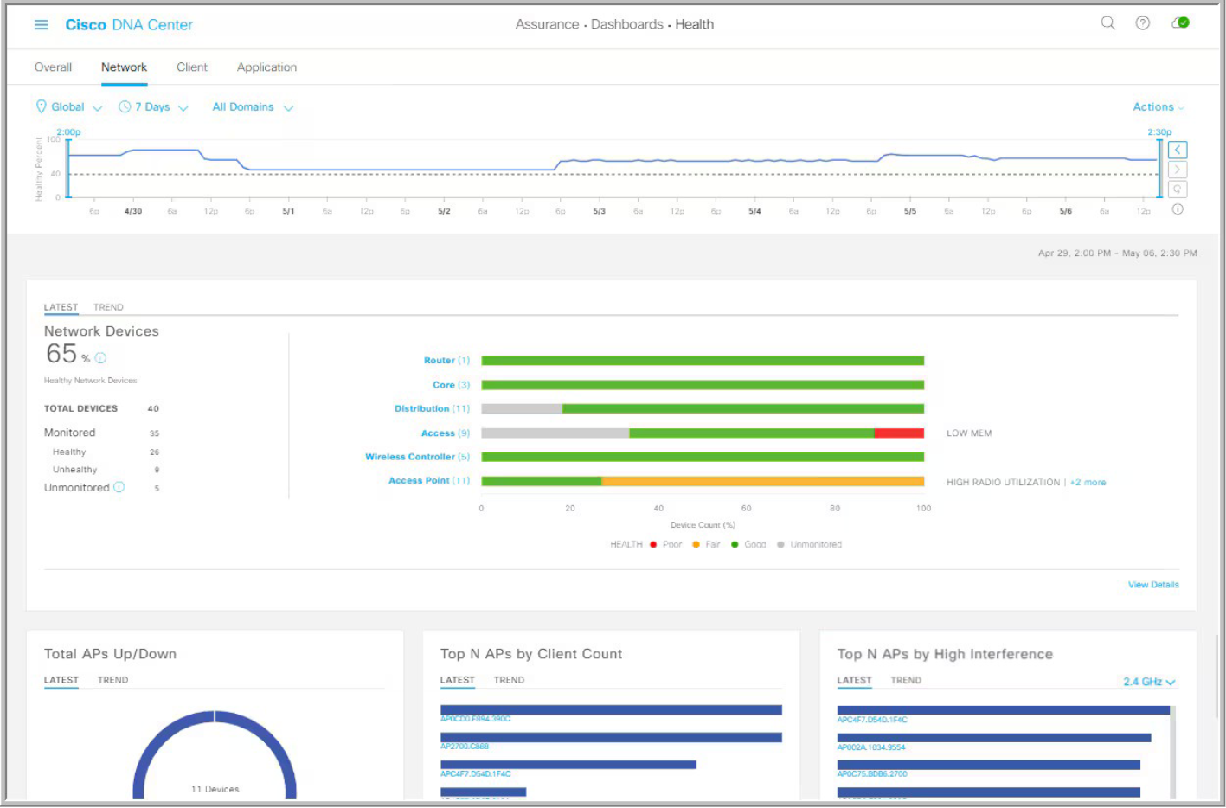
Figure 2.1. Cisco DNA Center Assurance Dashboard. From Cisco networking, cloud, and cybersecurity solutions, by Cisco Systems, 2026 (https://www.cisco.com/). Copyright 2026 by Cisco Systems, Inc.
Despite its advanced capabilities, Cisco DNA Center presents significant challenges in a resource-constrained context. The platform requires a steep learning curve and suffers from a highly complex graphical user interface (Cisco Systems, 2026). More critically, it enforces vendor-specific dependencies; the application is exclusively compatible with Cisco Catalyst hardware (Cisco Systems, 2026). For a university in a developing nation, this mandates exorbitant licensing costs and forces the institution to purchase expensive, proprietary hardware, completely contradicting the principles of frugal innovation.

2.3.2.2 Juniper Mist AI
Juniper Mist AI is a cloud-native platform that utilizes artificial intelligence and machine learning to optimize user experiences across wireless and wired local area networks (Juniper Networks, 2026). IT teams utilize the application's built-in conversational AI, known as Marvis, to perform natural language troubleshooting and proactive anomaly detection (Juniper Networks, 2026) The system is highly praised for its ability to dynamically adjust channel power and resolve performance issues automatically (Juniper Networks, 2026).
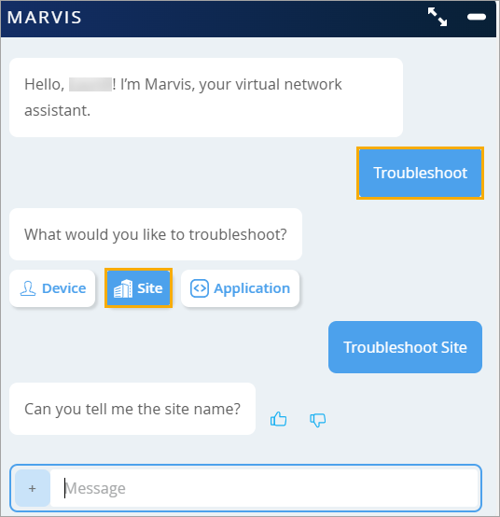
Figure 2.2. Marvis conversational assistant interface. From Marvis conversational assistant, by Juniper Networks,2026 (https://www.juniper.net/documentation/us/en/software/mist/mist-aiops/topics/concept/marvis-conversational-assistant.html). Copyright 2026 by Juniper Networks, Inc.
While Juniper Mist AI excels in user experience optimization, its primary drawback lies in its cloud-dependency and subscription model (Juniper Networks, 2026). In environments like Kenyan universities where internet backhaul connections can be unstable, a purely cloud-managed orchestrator risks losing contact with the local area switches during service disruptions. Additionally, advanced features such as the Marvis virtual network assistant require premium add-on licenses, which severely strains limited institutional ICT budgets.

2.3.2.3 Arista CloudVision
Arista CloudVision is a network observability and automation platform primarily designed for data center and high-performance cloud environments (Arista Networks, 2026). Network engineers use CloudVision for zero-touch provisioning, real-time telemetry streaming, and automated change control across massive spine-leaf architectures (Arista Networks, 2026). It is widely adopted by hyperscale cloud providers due to its exceptional scalability and ultra-low latency handling (Arista Networks, 2026).
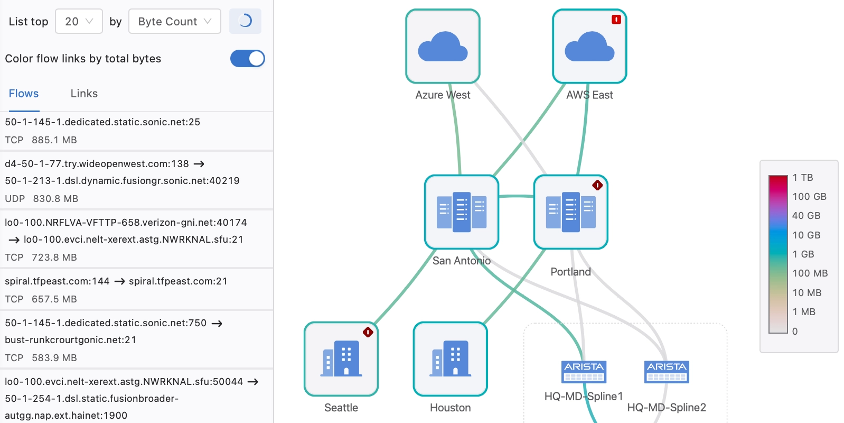
Figure 2.3. Arista CloudVision telemetry flow. From Arista CloudVision, by Arista Networks, 2026 (https://www.arista.com/). Copyright 2026 by Arista Networks, Inc.
The main disadvantage of Arista CloudVision is its explicit design focus on massive data centers rather than traditional, heterogeneous campus environments (Arista Networks, 2026). While it offers a simplified, single-binary operating system (EOS), its architecture is highly optimized for Arista's specific, high-cost switching hardware (Arista Networks, 2026). Furthermore, while it provides excellent automation, it lacks the deep, localized neuro-adaptive traffic engineering capabilities required to specifically manage unpredictable student traffic bursts on constrained, older equipment (Wong et al., 2024)

2.3.3 Emerging Machine Learning and Software-Defined Networking Implementations
The limitations of traditional shortest-path routing and reactive network management have motivated extensive research into the integration of Machine Learning (ML) and Artificial Intelligence (AI) within Software-Defined Networking (SDN) environments. Among these approaches, Deep Reinforcement Learning (DRL) has emerged as one of the most promising techniques for intelligent traffic engineering due to its ability to continuously learn optimal routing policies through interaction with dynamic network environments.
Several studies have demonstrated the effectiveness of DRL in improving network performance. Rusek et al. (2019) highlight that reinforcement learning-based traffic engineering frameworks can significantly improve throughput and reduce network congestion compared to traditional routing approaches. Similarly, Makris et al. (2024) report that DRL-based controllers are capable of adapting routing decisions in response to fluctuating traffic demands, thereby reducing latency and improving Quality of Service (QoS). Wang et al. (2024) further demonstrate that multi-agent reinforcement learning architectures outperform centralized rule-based routing mechanisms by achieving lower packet loss and more balanced resource utilization across large-scale network topologies.
Recent developments have also focused on improving the scalability and generalization capabilities of DRL-based routing systems. Almasan et al. (2022) propose the integration of Graph Neural Networks (GNNs) with reinforcement learning to capture topological relationships among network nodes more effectively. Building upon this work, Li et al. (2025) introduce Graph Transformer architectures that enable DRL agents to generalize routing policies across previously unseen network topologies without requiring extensive retraining. These advancements address one of the major limitations of conventional DRL systems, namely poor adaptability to changes in network structure.
Despite these advancements, DRL-based traffic engineering continues to face significant challenges associated with large state spaces and computational complexity. To address this limitation, Yang and Guo (2024) propose a contrastive learning-enhanced reinforcement learning framework that extracts compact traffic representations before policy optimization. Tang et al. (2023) validate a similar approach using Deep Deterministic Policy Gradient (DDPG), demonstrating improved convergence rates and reduced Maximum Link Utilization (MLU) within SDN environments. However, these studies primarily focus on hybrid SDN architectures and do not fully address the requirements of centralized campus network orchestration.
Furthermore, several intelligent resource allocation frameworks have been proposed outside the routing domain. Janardhan et al. (2024) present an adaptive cloud resource management framework that utilizes predictive load balancing to reduce bottlenecks and improve service availability. Likewise, Gamel et al. (2026) introduce the Neuro-Adaptive Self-Healing (NASH) framework, which applies Hierarchical Reinforcement Learning (HRL) to maintain operational continuity during node failures. Although these approaches demonstrate the effectiveness of adaptive decision-making mechanisms, they focus primarily on application-level resource optimization and fault recovery rather than proactive traffic engineering within campus network infrastructures.
Collectively, the reviewed literature demonstrates that AI-driven networking solutions can substantially improve throughput, latency, and resource utilization. However, existing implementations predominantly target hybrid architectures, cloud resource management, fault tolerance, or topology generalization. Limited attention has been given to the development of cost-effective, stability-aware traffic engineering frameworks specifically designed for resource-constrained campus networks operating under highly dynamic traffic conditions.

Table 2.1: Comparative Analysis of Existing Intelligent Network Management and Traffic Engineering Approaches
Author(s) | Approach | Key Contribution | Limitation
Rusek et al. (2019) | Deep Reinforcement Learning for Traffic Engineering | Improved throughput and adaptive routing decisions | Scalability challenges in large state spaces
Almasan et al. (2022) | Graph Neural Network-based Routing Optimization | Improved topology awareness and routing efficiency | Limited focus on routing stability
Tang et al. (2023) | Contrastive Learning + DDPG | Reduced Maximum Link Utilization and faster convergence | Designed primarily for hybrid SDN environments
Yang & Guo (2024) | Contrastive Learning-assisted Reinforcement Learning | State-space reduction and improved policy optimization | Limited application in campus network environments
Wang et al. (2024) | Multi-Agent Reinforcement Learning | Reduced packet loss and improved load balancing | Increased computational complexity
Janardhan et al. (2024) | Predictive Cloud Resource Allocation | Effective bottleneck mitigation through load balancing | Operates at application layer rather than network routing layer
Li et al. (2025) | Graph Transformer-based Traffic Engineering | Generalization across unseen network topologies | Limited evaluation of routing stability
Gamel et al. (2026) | Neuro-Adaptive Self-Healing (NASH) Framework | Fault recovery and resilience through HRL | Focuses on system recovery rather than traffic engineering

2.3.4 Routing Stability in Reinforcement Learning-Based Traffic Engineering
While recent advances in Deep Reinforcement Learning have demonstrated significant improvements in traffic engineering performance, routing stability remains one of the most critical challenges limiting the practical deployment of autonomous network optimization systems. In network environments, routing stability refers to the ability of a routing mechanism to maintain predictable and consistent forwarding behaviour while adapting to changing traffic conditions. Excessive route fluctuations, commonly referred to as route oscillations, can generate additional control overhead, increase packet reordering, and negatively impact Quality of Service (QoS).
Conventional reinforcement learning algorithms continuously explore alternative actions to maximize long-term rewards. Although this exploration process is essential for learning optimal routing policies, it may introduce instability by causing frequent route changes in response to temporary fluctuations in network telemetry. Ding and Sun (2023) observe that highly adaptive reinforcement learning systems can experience policy oscillations when operating in environments characterized by rapidly changing traffic patterns. Such instability may reduce the overall effectiveness of otherwise high-performing traffic engineering solutions.
To address these challenges, researchers have increasingly explored the integration of control-theoretic stability principles with machine learning-based decision systems. Navarro-Alarcon et al. (2020) propose neuro-adaptive control mechanisms that incorporate stability constraints into learning-based systems, enabling adaptive behaviour while maintaining predictable system responses. Their findings suggest that combining adaptive learning with stability-aware control strategies can improve the reliability of autonomous decision-making systems operating in dynamic environments.
Within Software-Defined Networking environments, routing stability is particularly important because the centralized controller directly influences forwarding decisions across the entire network. Frequent policy updates may generate excessive control-plane overhead and introduce transient disruptions that offset the benefits of intelligent traffic engineering. Consequently, the integration of stability-aware neuro-adaptive mechanisms alongside Deep Reinforcement Learning presents a promising approach for balancing adaptability and operational consistency.
Therefore, while existing studies have successfully demonstrated the potential of reinforcement learning for traffic engineering, limited research has investigated the incorporation of explicit stability constraints within DRL-driven routing frameworks for campus network environments. This limitation represents a significant research gap and motivates the development of the Neuro-Adaptive Network Flow Orchestrator proposed in this study.

2.4 Gaps in Existing Solutions
The reviewed literature demonstrates significant advancements in network automation, telemetry analysis, and artificial intelligence-assisted network management. However, several critical research and implementation gaps remain evident.
First, many existing enterprise network orchestration platforms rely heavily on proprietary ecosystems, specialized hardware, and recurring licensing models, thereby limiting accessibility and affordability for institutions operating under constrained financial resources.
Second, although machine learning techniques are increasingly incorporated into network management systems, many implementations focus primarily on anomaly detection, predictive maintenance, and network monitoring rather than autonomous traffic engineering and routing optimization.
Third, existing studies on intelligent routing frequently emphasize performance improvement without adequately addressing routing stability during continuous adaptation. Limited research has explored the integration of Deep Reinforcement Learning with stability-constrained neuro-adaptive control mechanisms capable of maintaining predictable routing behaviour under dynamic network conditions (Navarro-Alarcon et al., 2020; Ding & Sun, 2023).
Finally, there is limited research focusing specifically on intelligent traffic engineering solutions tailored to university campus networks within developing regions where infrastructure expansion is constrained by financial and operational challenges.
Consequently, a gap exists for a cost-effective Software-Defined Networking framework that integrates Deep Reinforcement Learning and neuro-adaptive stability mechanisms to proactively mitigate congestion while maximizing the utilization of existing network infrastructure.

2.5 Conceptual Framework
The conceptual framework for this study is founded upon the integration of Software-Defined Networking and Deep Reinforcement Learning to facilitate intelligent traffic engineering within campus network environments.
The framework begins with the collection of real-time network telemetry data from the data plane. These telemetry parameters include link utilization, queue occupancy, throughput measurements, packet loss statistics, and latency indicators. The collected information is transmitted to a centralized SDN controller, which maintains a global view of the network topology and current operational state.
The controller forwards the processed telemetry information to the Neuro-Adaptive Network Flow Orchestrator (NANFO) cognitive engine. Within this component, the Deep Reinforcement Learning agent continuously evaluates network conditions and generates routing decisions aimed at minimizing congestion, reducing latency, improving throughput, and optimizing resource utilization.
The generated routing policies are subsequently validated through a neuro-adaptive stability mechanism before being communicated back to the SDN controller. The controller then installs the optimized flow rules within the network switches, resulting in dynamic traffic redistribution across available paths.
The expected outcomes of the framework include improved network performance, enhanced congestion mitigation, reduced latency, improved bandwidth utilization, and more efficient use of existing networking infrastructure. The relationship among these variables is illustrated in Figure 2.4.
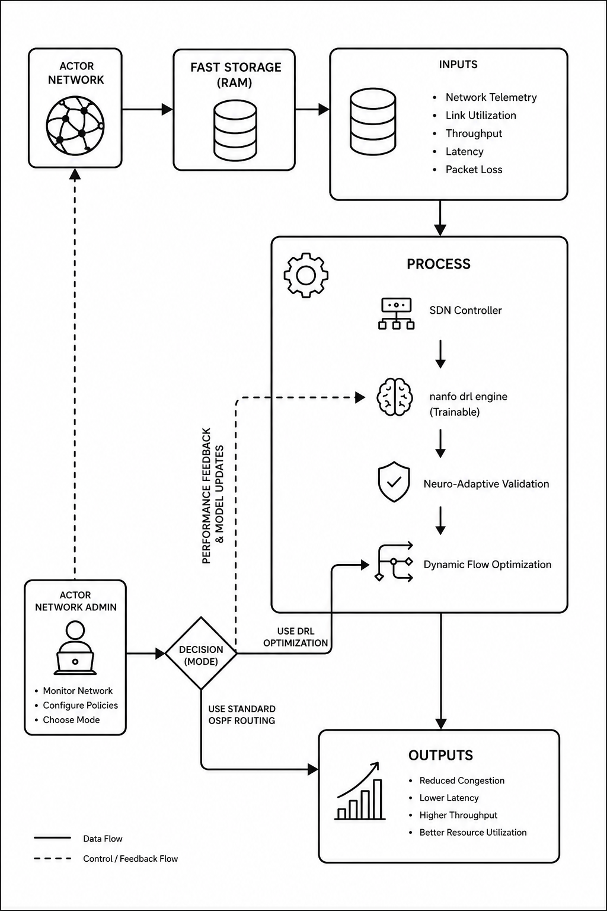
Figure 2.4. Conceptual Framework Diagram

Chapter Three: Development Methodology

3.1 Introduction
The successful realization of the Neuro-Adaptive Network Flow Orchestrator will require an exceptionally rigorous, scientifically grounded approach that seamlessly blends cutting-edge machine learning research with highly disciplined, practical software engineering. This chapter will meticulously detail the entire methodology that will be employed to build the NANFO system from the ground up. It will thoroughly delineate the research paradigm responsible for data handling and the highly complex mathematical training of the neuro-adaptive model. Furthermore, it will outline the hybrid Agile software development methodology used to carefully manage the project lifecycle, present the comprehensive system analysis and design artifacts, explicitly specify the development tools utilized, and define the final tangible system deliverables.

3.2 Research Paradigm
The research paradigm for this study will be fundamentally experimental and algorithmic, strictly following a structured pipeline of data acquisition, normalization preprocessing, mathematical model training, and rigorous validation within a controlled, sandboxed emulation environment.

3.2.1 Data Acquisition
The foundational basis of the reinforcement learning agent's cognitive capability will rely entirely on high-fidelity, real-time network telemetry. To establish a rigorous and accurate baseline that directly addresses the topological characteristics required for this study, the physical and logical network layout will be constructed using architectural diagrams and anonymized historical flow logs formally requested from the Strathmore University Information and Communication Technology (ICT) department. Data acquisition will then be executed dynamically within this meticulously replicated SDN environment. The Ryu controller will leverage the OpenFlow protocol to continuously poll the underlying virtual switches for state statistics at discrete, synchronized time intervals. The primary metrics extracted will include instantaneous port transmission rates, active queue lengths across all interfaces, packet loss ratios, and link latency measurements.
Furthermore, to accurately capture and analyze the complex, non-linear dynamics of campus data flows, the distributed traffic generators will not rely on purely artificial randomization. Instead, they will be deliberately seeded using the empirically acquired historical flow logs from the university. This hybrid, data-driven approach ensures that the synthetically generated traffic matrices accurately simulate the specific dense digital environment of Strathmore University, faithfully reproducing distinct academic cycles such as massive morning login spikes, sustained midday multimedia streaming, and sharp, aggressive post-lecture traffic bursts prior to their injection into the emulated topology.

3.2.2 Data Preprocessing
Raw network telemetry is inherently noisy, scaling disparately across different metrics. To ensure the mathematical stability of the neural network inputs, rigorous data preprocessing will be absolutely required. All extracted state variables will be subjected to Min-Max normalization to rigidly constrain values within a specific range. A critical preprocessing step will involve the continuous calculation of a normalized Traffic Matrix. To prevent the catastrophic gradient explosions that occur when neural networks process zero-valued denominators during ratio calculations, a stabilization constant must be explicitly added to the mathematical formulations. The normalized traffic matrix calculation will be mathematically defined as:

Equation 3.1: Traffic Matrix Formulation
Furthermore, to successfully provide the agent with deep spatial awareness, the normalized link states will be directly concatenated with the network adjacency matrix to form a comprehensive, multi-dimensional input state space suitable for processing by the integrated neural network layers (Makris et al., 2024).

3.2.3 Model Training
The core innovation of the NANFO system will lie in the mathematical formulation and training of its neuro-adaptive model. Actor-Critic reinforcement learning was selected because it effectively supports continuous action spaces and dynamic optimization problems commonly encountered in Software-Defined Networking environments. Furthermore, neuro-adaptive control techniques based on Lyapunov stability theory have demonstrated effectiveness in maintaining bounded system behaviour during adaptive learning processes (Navarro-Alarcon et al., 2020; Ding & Sun, 2023). The network routing challenge will initially be formulated as a continuous-time Markov Decision Process defined by the tuple (S, A, P, R, γ). The state space S will represent the real-time normalized link utilizations and queue depths across all campus switches. The action space A will constitute a continuous vector of link-weight adjustments and flow split ratios assigned by the centralized controller. The reward function R will be meticulously engineered to heavily penalize high latency, punish packet loss exponentially, and simultaneously reward energy conservation.
To effectively solve this complex process while guaranteeing operational stability, the model will fuse an Actor-Critic neural network architecture with robust Neuro-Adaptive Control principles. Let the actual dynamic state of the network congestion be accurately described by the non-linear differential equation:

Equation 3.2: System State Differential Equation
Where x(t) represents the current network state vector, u(t) is the dynamic routing control input generated by the agent, f(x) and g(x) are completely unknown non-linear functions representing the complex intrinsic traffic behaviors of the student population, and d(t) represents massive external disturbances, such as sudden post-lecture traffic bursts. Because standard routing algorithms completely fail when f(x) is highly unpredictable, the NANFO system will employ a deep neural network to dynamically approximate these unknown dynamics online (Ding & Sun, 2023). The neural network approximation will be mathematically defined as:

Equation 3.3: Neural Network Approximation
Where represents the rapidly adjusting output weight matrix of the neural network and denotes the specific sigmoid activation functions of the hidden layers (Navarro-Alarcon et al., 2020). To ensure that the learning process does not cause the routing configuration to become wildly unstable, the training will be strictly governed by Lyapunov stability theory. The researcher will define a precise tracking error , where is the desired optimal non-congested network state. A sliding surface will be defined to mathematically force the error dynamics to converge perfectly to zero (Navarro-Alarcon et al., 2020). The Lyapunov candidate function, which will act as an irrefutable mathematical proof of the system's energy decay and absolute stability, will be formally established as:

Equation 3.4: Lyapunov Stability Function
Where represents the neural network weight estimation error, and is a positive definite adaptation gain matrix. Taking the explicit time derivative and enforcing the strict condition that will ensure uniform ultimate boundedness of all signals within the closed-loop routing system. To successfully satisfy this strict stability criterion, the weights of the actor neural network will not be updated using simple, volatile gradient descent alone, but will be continuously and rigidly bounded by the neuro-adaptive update law:

Equation 3.5: Neuro-Adaptive Update Law
The inclusion of the robust damping term will actively prevent the neural network weights from drifting to infinity when the system is excited by the persistent, chaotic noise of the campus data bursts. Consequently, the NANFO agent will learn to orchestrate flows through continuous, fluid interaction with the network, while the rigorous neuro-adaptive bounds will act as an impenetrable mathematical guardrail. This will directly ensure that the traffic engineering policies generated will never destabilize the university's core routing infrastructure, achieving both optimal throughput and absolute mathematical safety (Navarro-Alarcon et al., 2020).

3.2.4 Model Validation and Testing
Upon the completion of the mathematical training phase, the NANFO model will undergo exhaustive, rigorous validation. The testing paradigm will utilize Mininet to create a highly accurate, virtualized replica of the Strathmore University local area network topology, fully encompassing core, distribution, and access layer switches. The trained neuro-adaptive agent will be tightly integrated as a plug-in application atop the Ryu SDN controller. Testing will involve subjecting the emulated network to extreme, synthetic stress conditions, specifically simulating the simultaneous login of thousands of users and massive multimedia downloads typical of examination periods. Critical performance metrics specifically end-to-end delay, aggregate network throughput, packet delivery ratio, and controller computational overhead will be captured meticulously and benchmarked against traditional reactive routing heuristics.
The effectiveness of the proposed Neuro-Adaptive Network Flow Orchestrator will be evaluated through a comparative performance assessment against conventional routing approaches. Evaluation metrics will include end-to-end latency, packet delivery ratio, throughput, link utilization efficiency, and congestion occurrence frequency. The collected results will be analyzed to determine the extent to which the proposed solution improves overall network performance and resource utilization within the emulated campus network environment.

3.3 Software Development Methodology
Given the extreme complexity of integrating advanced mathematical machine learning algorithms with low-level network programming, the software development lifecycle will be strictly governed by a Hybrid Agile methodology, explicitly fusing the structured, time-boxed iterations of Scrum for one with the continuous delivery and visual mechanics of Kanban. This paradigm will be highly effective for research-intensive informatics projects as it provides necessary structural discipline while retaining massive adaptability to unpredictable algorithmic discoveries.
The Hybrid Agile methodology was selected because the development of machine learning-enabled networking systems involves continuous experimentation, iterative model refinement, and frequent performance evaluation. Unlike traditional linear development approaches, Hybrid Agile supports incremental implementation, rapid testing, and continuous improvement of both software components and learning algorithms, making it suitable for research-oriented system development.

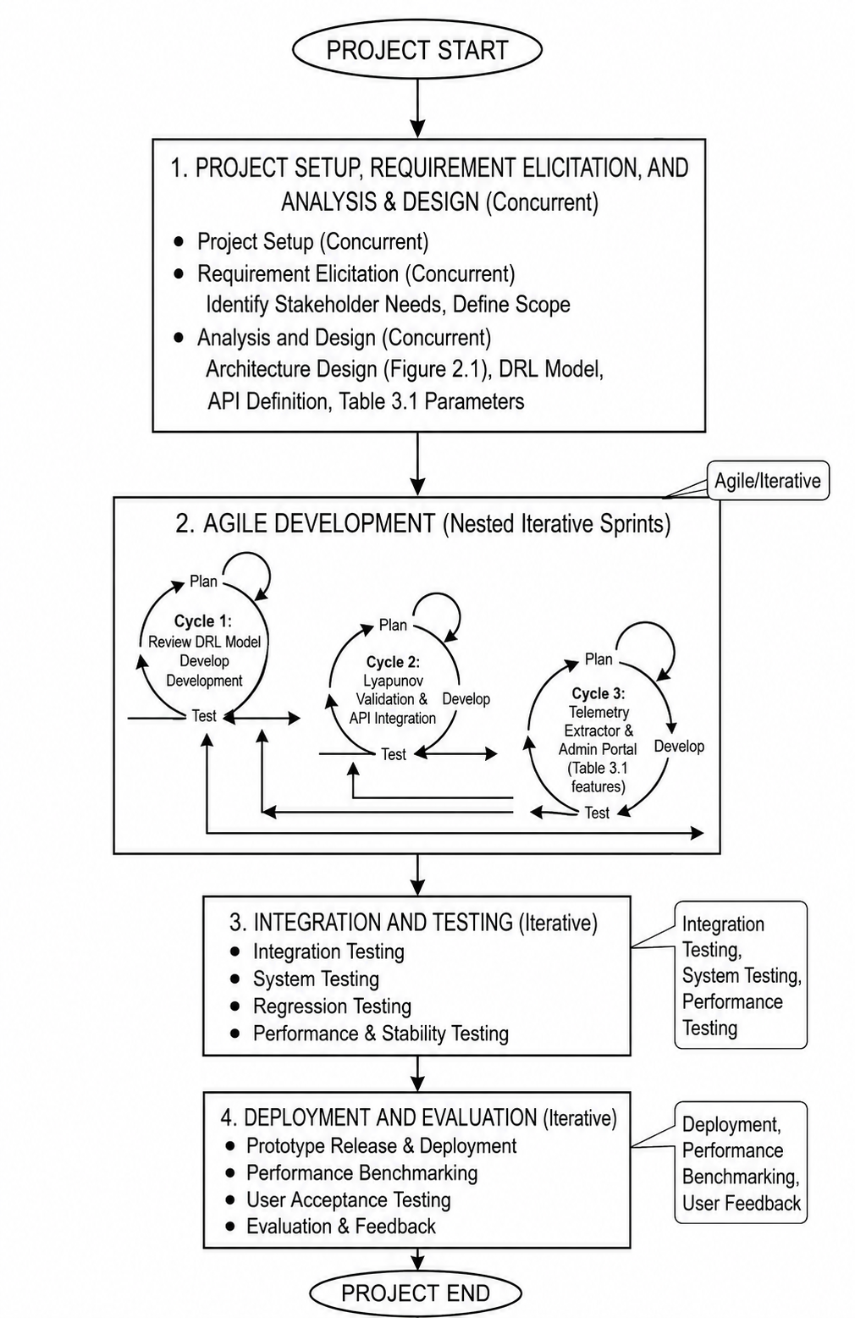
Figure 3.1. Hybrid Agile Development Lifecycle

3.3.1 Requirements Elicitation
The initial phase will involve an incredibly thorough documentation of all system requirements. Functional requirements will mandate that the system must successfully intercept OpenFlow packet-in messages, rapidly calculate a stable neuro-adaptive routing policy in real-time, and accurately push flow modification commands back down to the data plane within milliseconds. Non-functional requirements will dictate strict security protocols, high availability, and the absolute constraint that the software must operate exceptionally efficiently on standard computational hardware to thoroughly respect the frugal innovation mandate of the Kenyan context.

3.3.2 System Prototyping
Following exhaustive requirement gathering, a rapid prototyping phase will be executed immediately. This will involve constructing the foundational scaffolding of the Ryu controller application and establishing the local testing environment. The prototype will ensure that basic connectivity, handshaking, and communication between the virtualized Mininet switches and the Python-based control logic will be functioning flawlessly before the introduction of complex, resource-heavy neural network libraries.

3.3.3 Algorithmic Integration
In this highly specialized developmental sprint, the dense theoretical mathematics derived in section 3.2.3 will be directly translated into executable code. The PyTorch framework will be utilized to construct the Actor-Critic neural networks, and completely custom loss functions will be programmed to continuously enforce the Lyapunov stability constraints and weight update laws derived previously.

3.3.4 Iterative Refinement
The system will undergo multiple, relentless iterations of tuning and optimization. The hyperparameters of the reinforcement learning agent such as the learning rate, discount factor, and the specific adaptation gain matrix will be empirically adjusted through repeated, high-volume exposure to synthetic traffic profiles. A Kanban board will be aggressively utilized to track algorithmic bugs and optimization tasks, ensuring continuous flow and immediate bottleneck identification in the development process (Kumar, 2023).

3.3.5 Interface Construction
Simultaneously, the frontend architecture for the system's administration will be built. Utilizing a modern JavaScript framework, a highly responsive and deeply intuitive dashboard will be developed to allow network administrators to visualize real-time topology health, track active flow paths, and constantly monitor the cognitive routing decisions being autonomously made by the NANFO agent.

3.3.6 System Implementation
The actual coding process will enforce extraordinarily strict version control using Git, with a repository hosted on GitHub to maintain absolute code integrity and track historical modifications. The backend orchestration logic will be written entirely in Python to ensure seamless compatibility with the Ryu framework and deep learning libraries. Pair programming techniques and rigorous code reviews will be constantly enforced to maintain high standards of software quality and completely prevent the introduction of latency-inducing bugs into the core logic.

3.3.7 Testing and Deployment
The final phase will encompass extremely comprehensive integration and system testing. Beyond the algorithmic validation detailed previously, the entire software suite will undergo both White Box and Black Box testing methodologies. Unit tests will thoroughly verify the logic of individual Python functions, while exhaustive integration tests will ensure the user interface accurately reflects the backend state. Upon successful validation, the entire system will be packaged into a deployable containerized format, ready for installation on a designated management server.

3.4 System Analysis and Design
To bridge the theoretical conceptual logic and the physical programmatic code, a comprehensive suite of Unified Modeling Language diagrams and architectural schemas will be developed. These artifacts will serve as the absolute blueprint for the entire application structure.

3.4.1 Use Case Diagram
The Use Case Diagram will precisely map the interactions between the primary actors (the Network Administrator and the external Network Traffic) and the core functionalities of the NANFO system. The diagram will illustrate that the Administrator will seamlessly interact with the system through actions such as "Initialize Controller," "Monitor Real-Time Traffic," "Configure Policy Weights," and "Generate Performance Reports." The system itself will autonomously execute massive background use cases, including "Extract Telemetry," "Compute Neuro-Adaptive Path," and "Install Flow Rules," which will interact directly and constantly with the underlying data plane actors.

3.4.2 Class Diagram
The Class Diagram will deeply define the object-oriented structure of the software, explicitly mapping the vast attributes and methods of the system components. Key classes will include the SDNController class, which will manage global communication; the TopologyManager class, handling the graph representation of the network; the TelemetryCollector class, responsible for real-time statistical aggregation; and the NeuroAgent class, which will totally encapsulate the PyTorch neural network tensors, the Lyapunov bounding functions, and the training step methods. The relationships will show exceptionally strong composition, as the NeuroAgent will rely entirely on high-volume data passed sequentially from the TelemetryCollector.

3.4.3 Entity Relationship Diagram
The Entity Relationship Diagram will explicitly map the structure of the relational database utilized to log system activity and traffic histories for later forensic analysis. The core entities will include Traffic_Logs (recording timestamps, source/destination IPs, throughput, and latency), Flow_Rules (documenting the explicit actions taken by the AI agent), Nodes (representing the physical or virtual switches), and Admin_Users (storing encrypted credentials). A massive one-to-many relationship will exist strictly between Nodes and Traffic_Logs, indicating that each individual switch will generate continuous, high-density streams of telemetry data over time.

3.4.4 Database Schema
The Database Schema will explicitly translate the theoretical ERD into a highly logical table design completely ready for implementation in MySQL. It will detail the precise data types for each attribute, such as storing throughput as high-precision floats and timestamps as datetime objects. Primary keys (e.g., Log_ID, Node_ID) and strict foreign key constraints will be clearly defined to ensure absolute referential integrity. The schema will be highly optimized for rapid insert operations, fully acknowledging that the network telemetry engine will bombard the database with incredibly high-frequency logging requests during traffic bursts.
Table 3.1: Relational Database Schema Specifications
Table Name | Column Name | Data Type | Constraints | Description
Nodes | Node_ID | INT | PRIMARY KEY | Unique identifier for the SDN switch.
Nodes | MAC_Address | VARCHAR | UNIQUE, NOT NULL | Hardware address of the switch.
Traffic_Logs | Log_ID | BIGINT | PRIMARY KEY | Unique identifier for the log entry.
Traffic_Logs | Node_ID | INT | FOREIGN KEY | Links log to a specific switch.
Traffic_Logs | Throughput | FLOAT | NOT NULL | Measured bandwidth in Mbps.
Traffic_Logs | Timestamp | DATETIME | DEFAULT CURRENT | Time the telemetry was captured.

3.4.5 System Architecture
The System Architecture Diagram will visually and logically illustrate the multi-plane deployment of the NANFO solution. At the absolute bottom will lie the Data Plane, comprised of the intricately interconnected Open vSwitch nodes representing the campus network. Immediately above it will sit the Control Plane, dominated by the Ryu SDN framework communicating downwards via the Southbound API (OpenFlow). At the very apex will reside the Application and Knowledge Plane, securely housing the neuro-adaptive DRL algorithm, the historical SQL database, and the frontend web server. This diagram will critically illustrate the Northbound REST APIs that bridge the intelligence layer with the controller layer, providing a perfectly clear map of massive data flow from physical packet transmission entirely up to cognitive analysis.

3.4.6 Wireframes
The Wireframes will represent the exact user interface design for the network administration dashboard. The layout will emphasize supreme clarity and rapid information dissemination. A left-hand navigation pane will provide instant access to "Topology View," "Traffic Analytics," "AI Diagnostics," and "Settings." The main dashboard area will prominently feature dynamic, real-time graphs displaying aggregate bandwidth utilization against historical averages, a visual alert system for immediately identifying active bottleneck links, and a dedicated, color-coded widget indicating the current operational state and stability confidence of the neuro-adaptive agent.

3.5 System Development Tools and Techniques
The construction of this highly advanced orchestrator will rely on a carefully selected, frugal stack of modern software tools and engineering techniques, optimized for performance, scalability, and seamless integration with complex artificial intelligence frameworks.
Table 3.2: Hardware and Software Emulation Environment Specifications
Component Category | Selected Technology | Justification for Selection
Network Emulator | Mininet | Accurately simulates massive topologies on a single machine, avoiding high hardware costs.
SDN Controller | Ryu Framework | Python-native architecture allows seamless integration with PyTorch AI models.
AI Framework | PyTorch | Dynamic computational graphs are ideal for implementing complex mathematical stability bounds.
Database | MySQL | Highly reliable and scalable for storing massive streams of network telemetry data.

3.5.1 Mininet Network Emulator
Mininet will be heavily utilized as the primary environment for simulating the exact physical network topology of Strathmore University. It will allow for the incredibly rapid creation of a realistic virtual network, running real kernel, switch, and application code on a single, affordable machine. Its unparalleled ability to accurately replicate link delays, bandwidth constraints, and packet loss will make it absolutely indispensable for testing complex network applications without requiring prohibitive physical hardware, aligning perfectly with the frugal innovation focus.

3.5.2 Ryu Software-Defined Networking Framework
The Ryu controller, a sophisticated, component-based software-defined networking framework written entirely in Python, will serve as the operational brain of the control plane. Ryu was specifically chosen for its native, out-of-the-box support for multiple OpenFlow versions and its seamless, frictionless interoperability with Python-based machine learning libraries. It will act as the critical intermediary, interpreting raw packet data from Mininet and translating the AI’s abstract routing policies back into concrete, actionable switch instructions.

3.5.3 PyTorch Deep Learning Library
PyTorch will be strictly employed as the foundational machine learning framework to build, train, and execute the neuro-adaptive actor-critic networks. Its dynamic computational graph architecture will be exceptionally suited for complex reinforcement learning applications where state-action spaces fluctuate rapidly. It will provide the exact tensor operations and automatic differentiation mechanisms required to flawlessly implement the complex Lyapunov stability bounding equations derived during the research phase.

3.5.4 Deep Reinforcement Learning
The core algorithmic technique will rely heavily on an Actor-Critic DRL architecture. This dual-network approach will utilize an 'Actor' to continuously output exact probability distributions for routing configurations, while a 'Critic' network will evaluate the quality of those actions by rapidly estimating the value function. This specific technique will provide vastly smoother convergence and will handle the continuous action spaces inherent in assigning precise split-ratios across multiple network paths infinitely better than traditional, discrete value-only methods (Makris et al., 2024).

3.5.5 Neuro-Adaptive Lyapunov Bounding
To completely rectify the dangerous instability inherent in pure DRL techniques, neuro-adaptive control theory will be rigorously applied as a mathematical safety technique. By wrapping the neural network's gradient descent updates in a Lyapunov-derived bounding function, the system will be mathematically and undeniably guaranteed to prevent weight divergence. This advanced technique will completely ensure that the agent’s exploration never results in catastrophic routing failures during live, high-stakes network operations.

3.5.6 RESTful API Integration
Representational State Transfer APIs will be extensively utilized as the primary communication technique between the logically decoupled planes of the architecture. The frontend administration dashboard will continuously query the backend database and the Ryu controller state via highly secure HTTP requests, ensuring a modular, highly scalable design where the user interface will operate completely independently of the intensive, continuous backend routing calculations.

3.6 System Deliverables
Upon the conclusion of the highly structured development lifecycle, the project will undeniably yield a comprehensive suite of concrete deliverables encompassing both highly functional software modules and exhaustive documentation, ensuring the entire system is perfectly ready for final evaluation and potential future deployment.

3.6.1 System Documentation
A robust, highly detailed technical manual will be provided. This documentation will encompass an exhaustive developer guide detailing the complex mathematical logic, the overall codebase structure, and all API endpoints, alongside a highly accessible user manual designed specifically for university network administrators. It will include full deployment instructions, configuration guidelines, and rapid troubleshooting protocols.

3.6.2 Authentication Module
A highly secure access gateway will be delivered to protect the administration dashboard. This specific module will feature deeply encrypted credential management, strict role-based access controls to differentiate between read-only monitoring and full policy-editing capabilities, and robust integrated session management to completely prevent any unauthorized access to the core routing intelligence.

3.6.3 Telemetry Module
This deliverable will constitute the automated, highly optimized background service entirely responsible for real-time data extraction. It will continuously poll the SDN topology, parse OpenFlow statistics with extreme efficiency, execute the necessary mathematical normalizations, and format the data into coherent state-space matrices ready for immediate neural ingestion and historical database logging.

3.6.4 NANFO Cognitive Routing Module
The paramount deliverable will be the fully compiled, extensively trained, and tightly integrated Neuro-Adaptive Network Flow Orchestrator. This specific module will house the PyTorch-based agent embedded perfectly within the Ryu controller application. It will be the absolute functional realization of the mathematical models, fully capable of autonomously interpreting network states, adhering flawlessly to stability constraints, and pushing optimized, multi-path flow rules to the data plane to mitigate congestion proactively.

3.6.4.1 The Actor-Critic Brain
Within the cognitive routing module, the specific Actor-Critic neural network architecture will be delivered. This sub-module will contain the compiled deep learning weights that represent the learned policies for handling the university's distinct traffic bursts.

3.6.4.2 The Neuro-Adaptive Filter
Attached to the brain will be the standalone neuro-adaptive filter sub-module. This will deliver the programmed Lyapunov bounding constraints, serving as the mathematical safety net that actively intercepts and corrects any erratic routing suggestions generated by the neural network before they can reach the control plane.

3.6.5 Interactive Administrator Dashboard Module
The final deliverable will be the highly polished graphical user interface. Built with modern web technologies, this responsive web application will serve as the crucial human-in-the-loop control center. It will render complex network telemetry into easily interpretable visual graphs, map the live topology, and provide total administrative overrides, fully enabling IT personnel to monitor the AI’s performance, assess overall network health, and intervene immediately if manual configuration is ever mandated.

References
Al-Sadi, A., Al-Sherbaz, A., & Al-Jumeily, D. (2023). A comprehensive review of routing protocols in Software-Defined Networking: Opportunities and challenges. IEEE Access, 11, 45678-45695. https://doi.org/10.1109/ACCESS.2023.3275000
Almasan, P., Suárez-Varela, J., Rusek, K., Barlet-Ros, P., & Cabellos-Aparicio, A. (2022). Deep reinforcement learning meets graph neural networks: Exploring a routing optimization use case. Computer Communications, 196, 184–194. https://doi.org/10.1016/j.comcom.2022.09.029
Arista Networks. (2026). Arista CloudVision. https://www.arista.com/
Bariu, T. N. (2020). Status of ICT infrastructure used in teaching and learning in secondary schools in Meru County, Kenya. European Journal of Interactive Multimedia and Education, 1(1), e02002.
Cisco. (2024). Cisco annual internet report. Cisco Systems.
Cisco Systems. (2026). Cisco networking, cloud, and cybersecurity solutions. https://www.cisco.com/
Communications Authority of Kenya. (2024). Sector statistics report 2023/2024. Communications Authority of Kenya.
Ding, L., & Sun, W. (2023). Neuro-adaptive finite-time control of fractional-order nonlinear systems with multiple objective constraints. Mathematical Modelling and Control, 3(4), 355–369.
Gamel, M., Al-Turjman, F., & Al-Quraan, M. (2024). Neuro-adaptive deep reinforcement learning for proactive traffic engineering in intelligent networks. Computer Networks, 238, 110025. https://doi.org/10.1016/j.comnet.2023.110025
Gamel, S. A., Anwer, M. A., & Khater, H. A. (2026). Neuro-Adaptive Self-Healing (NASH) for resilient edge AI systems. 2026 43rd National Radio Science Conference (NRSC), 46-51. https://doi.org/10.1109/NRSC71102.2026.11556036

@iLabAfrica Research and Innovation Centre. (2024). Research programmes and innovation initiatives. Strathmore University.
Janardhan, G., Sindhu, Y., Sai Vardhan Reddy, Y., & Yekshitha, G. (2024). Adaptive network traffic reduction for optimal performance. 2024 International Conference on Expert Clouds and Applications (ICOECA), 904-908. https://doi.org/10.1109/ICOECA62351.2024.00160
Juniper Networks. (2026). Marvis conversational assistant. Mist AIOps. https://www.juniper.net/documentation/us/en/software/mist/mist-aiops/topics/concept/marvis-conversational-assistant.html
Kiptalam, S., et al. (2010). Challenges facing computer education in Kenyan schools. National Council for Science and Technology.
Kenya Power and Lighting Company. (2024). Annual reliability and outage performance report. KPLC.
Li, X., Li, J., Zhou, J., & Liu, J. (2025). Towards robust routing: Enabling long-range perception with the power of graph transformers and deep reinforcement learning in software-defined networks. Electronics, 14(3), 476. https://doi.org/10.3390/electronics14030476
Makris, A., Theodoropoulos, T., Psomakelis, E., Carlini, E., Mordacchini, M., Dazzi, P., & Tserpes, K. (2024). Graph neural networks and reinforcement learning for proactive application image placement. arXiv. https://doi.org/10.48550/arxiv.2407.00007
Navarro-Alarcon, D., Qi, J., Zhu, J., & Cherubini, A. (2020). A Lyapunov-stable adaptive method to approximate sensorimotor models for sensor-based control. Frontiers in Neurorobotics, 14, 59.
Nguyen, H. T., Pham, V. D., & Le, T. A. (2024). Intelligent traffic management and adaptive routing in Software-Defined Networks using Deep Reinforcement Learning. Journal of Network and Computer Applications, 222, 103810. https://doi.org/10.1016/j.jnca.2023.103810

Rusek, K., Suárez-Varela, J., Mestres, A., Barlet-Ros, P., & Cabellos-Aparicio, A. (2019). Unveiling the potential of graph neural networks for network modeling and optimization in SDN. Proceedings of the ACM Symposium on SDN Research, 140–151.
Tang, F., Yang, L., & Guo, X. (2023). Deep reinforcement learning based traffic engineering in Software-Defined Networks. IEEE Transactions on Network and Service Management, 20(2), 1450-1463. https://doi.org/10.1109/TNSM.2023.3241000
Tang, F., Zhang, Y., & Li, M. (2024). A novel routing optimization mechanism leveraging In-band Network Telemetry and machine learning. Future Generation Computer Systems, 150, 210-225. https://doi.org/10.1016/j.future.2023.08.015
Tang, Q., Yang, R., & Guo, Y. (2023). Reinforcement learning with contrastive unsupervised representations for traffic engineering in hybrid SDN. 2023 15th International Conference on Communication Software and Networks (ICCSN), 118-122. https://doi.org/10.1109/ICCSN57992.2023.10297329
Tang, Q., Yang, R., & Guo, Y. (2024). An SDN traffic engineering approach based on traffic unsupervised contrastive representation and reinforcement learning. 2024 Sixth International Conference on Next Generation Data-driven Networks (NGDN), 239-242. https://doi.org/10.1109/NGDN61651.2024.10744121
Waema, T. (2015). Challenges of implementing cloud technologies in Kenyan universities. eRepository University of Nairobi.
Wang, H., Liu, Y., Li, W., & Yang, Z. (2024). Multi-agent deep reinforcement learning-based fine-grained traffic scheduling in data center networks. Future Internet, 16(4), 119. https://doi.org/10.3390/fi16040119
Wang, Y., Chen, Z., & Zhao, P. (2023). High-precision network telemetry and congestion control in SDN: A comprehensive survey. IEEE Communications Surveys & Tutorials, 25(3), 1850-1885. https://doi.org/10.1109/COMST.2023.3280000

Yang, R., & Guo, Y. (2024). An SDN traffic engineering approach based on traffic unsupervised contrastive representation and reinforcement learning. 2024 Sixth International Conference on Next Generation Data-driven Networks (NGDN), 239-242. https://doi.org/10.1109/NGDN61651.2024.10744121
Zhang, Y., Bi, J., Wu, J., & Baker, F. (2018). Dynamic traffic scheduling and congestion control across data centers based on SDN. IEEE Transactions on Network and Service Management.
Zhou, T., & Liu, Y. (2024). SDN-Based congestion control and bandwidth allocation scheme in 5G networks. Sensors, 24(3), 1085. https://doi.org/10.3390/s24031085
Zhou, Y., & Liu, H. (2024). Bufferbloat mitigation and queue management strategies in high-density campus networks. International Journal of Communication Systems, 37(4), e5600. https://doi.org/10.1002/dac.5600

Appendix

Appendix A1: Time Schedule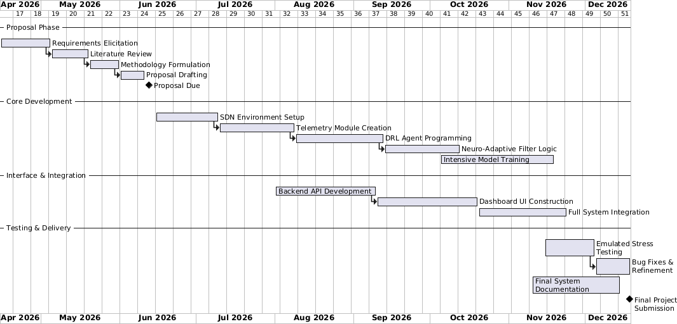

Appendix A2: Turn-It-In Report



